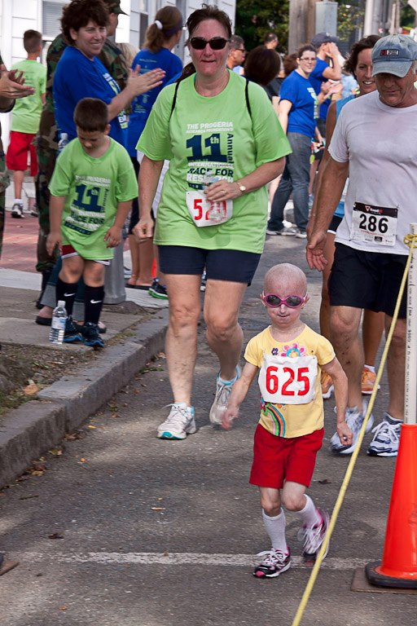
Progeria Research Foundation

YES! I want to be a sponsor for the

13th Annual International Race for Research

and help win this RACE against time!

Megan sprinting to the finish
at the 2012 race!

I will join (in person or in spirit!) the hundreds of families and runners on Saturday, September 6, 2014 in downtown Peabody to enjoy a fun-filled morning of exercise, refreshments, awards and entertainment.

My level of sponsorship is as follows:

- Starting Banner Sponsor, $1,000 (1 available)
Sponsorship includes: individual or business name and logo on the Starting Banner, t-shirts and PRF’s web site, and NEW this year, 3 posts on our Facebook page (436,000 Likes); and five entries in the race.

- Finish Banner Sponsor, $1,000 (1 available)
Sponsorship includes: individual or business name and logo on the Finish Banner, t-shirts and PRF’s web site, and NEW this year, 3 posts on our Facebook page (436,000 Likes); and five entries in the race.

- Mile Marker Sponsors, $500
Sponsorship includes: individual or business name and logo on one of the two Mile Marker signs, t-shirts and PRF’s web site, and NEW this year, 1 posts on our Facebook page (436,000 Likes); and three entries in the race.

- Watering Hole Sponsors, $250
Includes individual or business name on the Watering Hole sign, t-shirts and on PRF’s web site, with a link to your business web site; and two entries in the race.

- Foot Print Sponsors, $100
Will include one race entry and name on our web site.

Call Michelle Fino, 978-535-2594 or email mfino@progeriaresearch.org to become a sponsor!

Thank YOU! And hope to see you at the race!!

